LS1: You and your company

Presenting yourself

At X-Files, a company for data security in Hamburg, a first meeting is taking place among the apprentices. Each person should introduce themselves, including their background, hobbies and interests. The goal is to organise a social activity programme. Because some of the apprentices do not speak German, the meeting is held in English.

Task1: Introduction Round

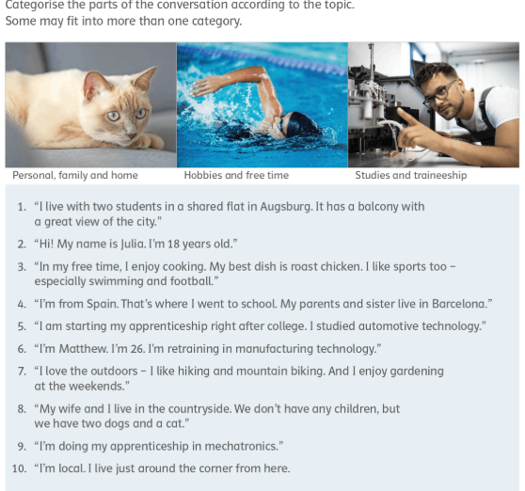

Task 2: For each statement write down a fitting question. Then come up with two more questions that could be asked at a first introduction meeting.



Task 3: Speed-dating

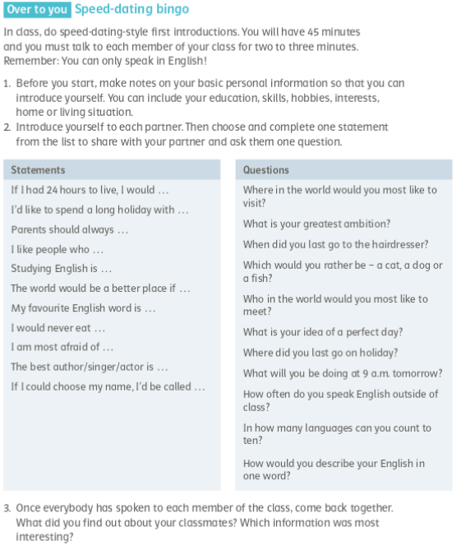

Vocab Section:

Important words Englisch | Deutsch | Eigene Beispielsätze, Definitionen, Synonyme, Antonyme, Wörter der Wortfamilie
apprenticeship | die Ausbildung
apprentice | der / die Auszubildende
client | der Kunde / die Kundin
colleague | der Kollege / die Kollegin
employment | die Anstellung; die Einstellung; die Beschäftigung
employee | der Arbeitnehmer / die Arbeitnehmerin; der / die Angestellte
to employ | einstellen; beschäftigen
headquarters (pl) | die Hauptgeschäftsstelle; die Zentrale
internship | das Praktikum
intern | der Praktikant / die Praktikantin

Grammar Section:
